# **Rotimi Ishola**

**PART 1: DEVELPING A BUYERS PERSONA**

**CLIENT NAME: SAM ADEYEMI**

**TARGET USER PERSONA**

**12.10.2020**

**User Persona:** IT oriented individual



**Gender:** Male

**Age:** 24

**Education:** Degree Educated – UNILAG.

**Income:** Extra Income, tends to buy products, sell brand.

**Interest affinities:** IT equipment, Software, AI and computers.

**Primary Discovery Methods:** Twitter, LinkedIn, Facebook, Instagram, Reviews from Blogger, Google, Bing.

**Primary Area of Residence:** Student campuses across all African higher institutions and colleges (Nigerian University, African university, online campus, etc).

**Issues to Solve**: Use of Information technology across Africa for the growth of young African technological development and beyond.

**Others:** Young and inquisitive, interested in technology, likely interested in leveraging on the market share.

Sam is a young man who is ambitious and concerned about how lack of IT and AI-power computer education is a disadvantage to young African development. AI-powered computer vision provides access to a visually rich array of customer insights, creates new customer experiences, and drives emotional engagement. As part of transformation efforts, retailers across African are piloting computer vision projects in various functional areas. Sam initiative idea is to bridge the gap between seller and users, and also between accessibility and development of young African student, who are hungry and inquisitive to develop Africa as a whole. Sam enjoy helping people through the use of technology and Artificial intelligent and continue on a mission of developing his community and population at large. To crown it all, we cannot underestimate the benefits of information technology to any developed society. I will quote one of my favourite quotes on computer usage: “I do not fear computers, I fear lack of them.” - Isaac Asimov.

**PART 2: KEYWORD RESEARCH**

Click the link to see the research work**:**

[**https://1drv.ms/x/s!AtI6wJbrV6Ajg3JpTp4nZDTqXqIB?e=RYeDcY**](https://1drv.ms/x/s!AtI6wJbrV6Ajg3JpTp4nZDTqXqIB?e=RYeDcY)

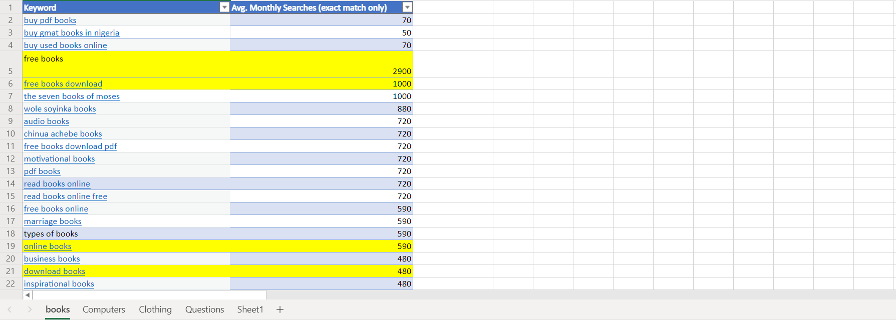

**PART 3: CONDUCTING A COMPETITIVE ANALYSIS**

Click the click to see the research work**:**

<https://1drv.ms/x/s!AtI6wJbrV6AjhAT7ErjhuxKkSgHm?e=9p6plB>

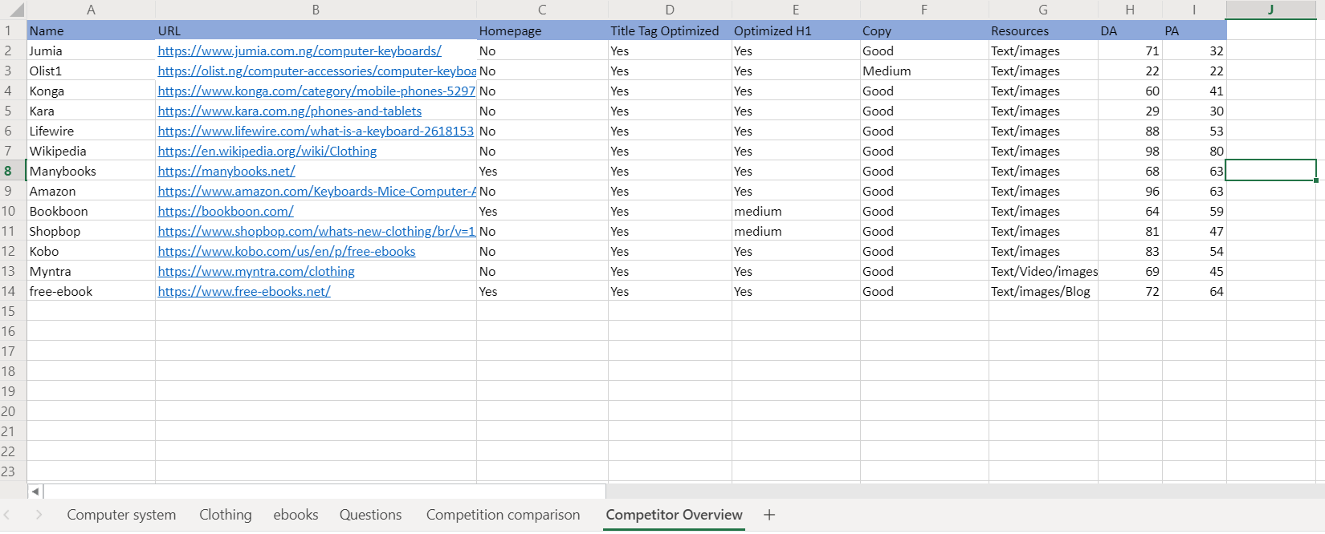

Phase 1: The reason why those keywords were chosen was the because of the Organic research percentage. The keywords were chosen because they are informational keywords and contain long-tail queries. Also, the keywords were chosen to not compete with each and base on the niche of the business.

Phase 2: Strategies

* Use more text and images to generate page authority
* Use video to capture more of domain authority
* Well written content and incorporation of good keywords
* Use of Social media to generate links